***Dt : 5/9/2022***

***\*imp***

***define Access Modifiers?***

***=>Access Modifiers will specify the scope of programming components***

***in project.***

***=>The following are some important access modifiers in Java:***

***(a)public***

***(b)private***

***(c)protected***

***(d)default***

***(a)public:***

***=>'public' programming components canbe used within the project.***

***(b)private:***

***=>'private' programming components are accessed only inside the***

***class.***

***(c)protected:***

***=>'protected' programming components are accessed only inside the***

***package,but the 'protected' programming components can also be used***

***by ChildClass outside the package.***

***(d)default:***

***=>The programming components which are declared without any access***

***modifiers in classes are considered as 'default'***

***=>'default' programming components are accessed only inside the***

***package.***

***diagram:***

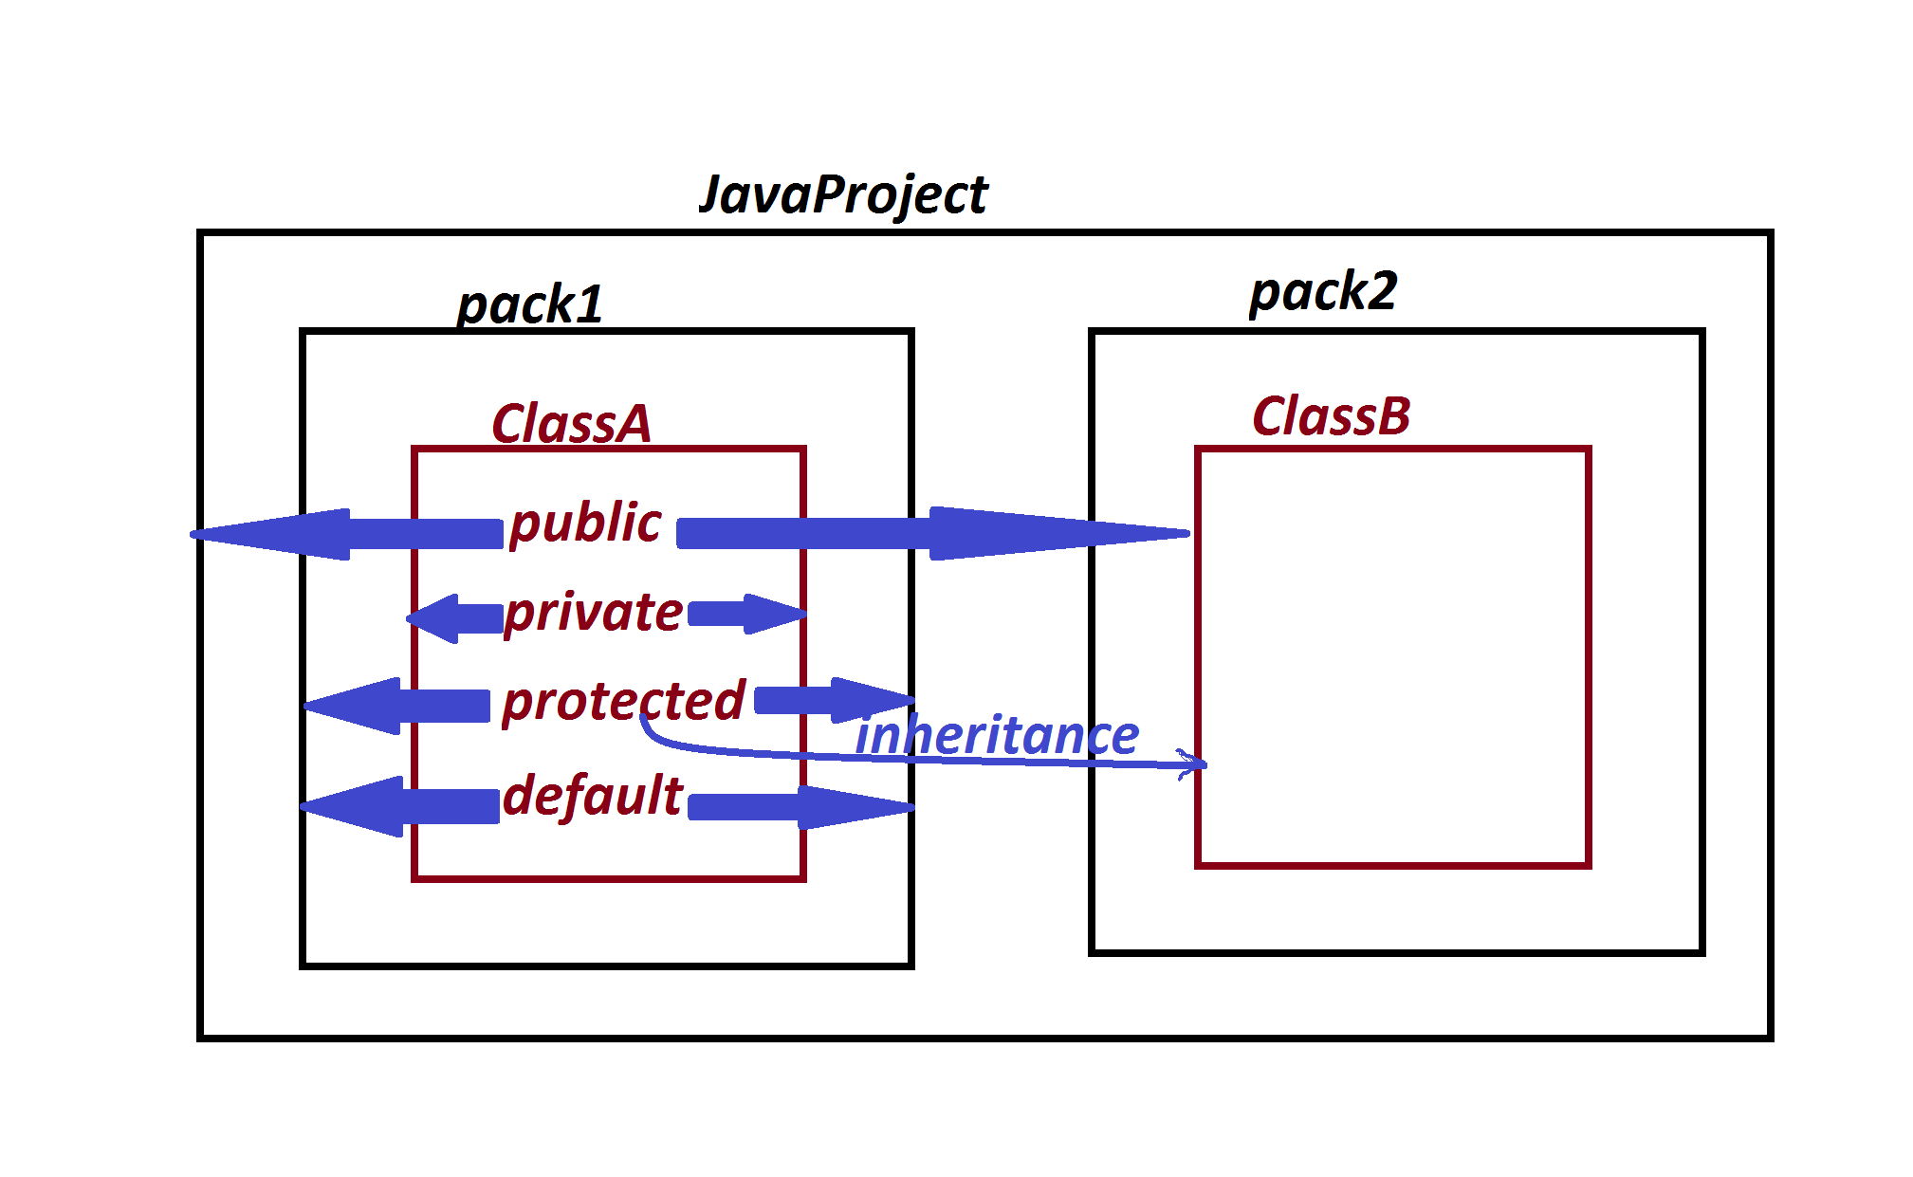

***==================================================***

***\*imp***

***define 'import' statement?***

***=>"import" statement specify to make class or interface available***

***from one package to another package.***

***=>Importing process in Java can be done in three ways:***

***(i)Using 'import package_name.Class_name/Interface_name; '***

***(ii)Using 'import package_name.*; '***

***(iii)Using 'Fully Qualified names'.***

***(i)Using 'import package_name.Class_name/Interface_name; '***

***=>In this importing process we specify the Class_name or***

***Interface_name available to current running process.***

***=>This importing process is also known as 'Explicit importing***

***process'***

***Ex:***

***import java.util.Scanner;***

***import p1.CalculateSalary;***

***-------------------------------------------------***

***(ii)Using 'import package_name.*; '***

***=>In this importing process all the classes and interfaces from***

***the package are available to current running program.***

***=>This importing process is also known as 'Implicit importing***

***process'.***

***Ex:***

***import java.util.*;***

***import p1.CalculateSalary;\****

***-----------------------------------------------------***

***(iii)Using 'Fully Qualified names'.***

***=>The process of declaring Classes and Interfaces with***

***package_names part of programming code are known as 'Fully Qualified***

***names'.***

***Ex:***

***java.util.Scanner s = new java.util.Scanner(System.in);***

***p1.CalculateSalary cs = new p1.CalculateSalary();***

***===========================================================***

***faq:***

***define 'static' import?***

***=>The process of declaring import statement with 'static' keyword***

***is known as 'static import',introduced by Java5 version.***

***syntax:***

***import static package_name.Class_name/Interface_name.*;***

***Advantage:***

***=>In 'static import' all the static members of Class or Interface***

***available to current running program,in this process we can access***

***static members directly without class_name or Interface_name.***

***=========================================================***